Some most used classification metrics are:
- Confusion Matrix: when we need to know how much samples we got right or wrong for each class. The values that were correct and correctly predicted are called true positives, the ones that were predicted as positives but weren't positives are called false positives. The same nomenclature of true negatives and false negatives is used for negative values;
- Precision: when our aim is to understand what correct prediction values were considered correct by our classifier. Precision will divide those true positive values by the samples that were predicted as positives;
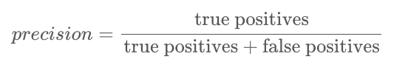

- Recall: commonly calculated along with precision to understand how many of the true positives were identified by our classifier. The recall is calculated by dividing the true positives by anything that should have been predicted as positive.
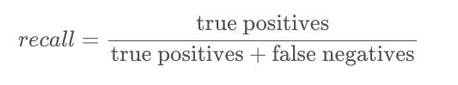

- F1 score: is the balanced or harmonic mean of precision and recall. The lowest value is 0 and the highest is 1. When F1 score is equal to 1, it means all classes were correctly predicted - this is a very hard score to obtain with real data (exceptions almost always exist).
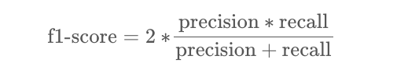

In the classification report, linear SVM has an accuracy of 0.86; RBF 0.90 and polynomial 0.87.
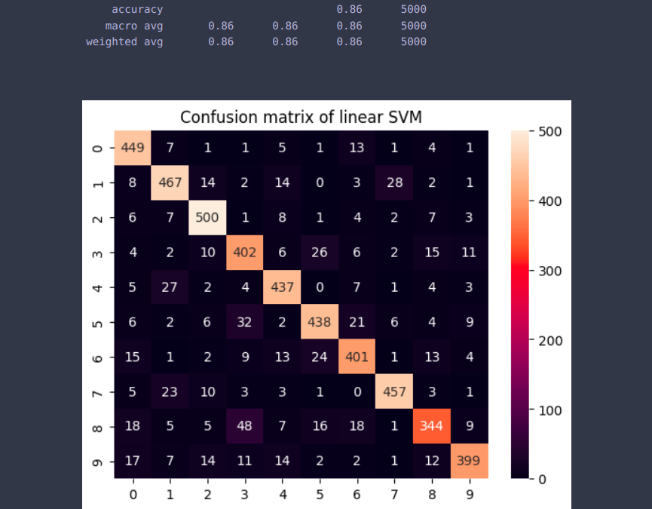
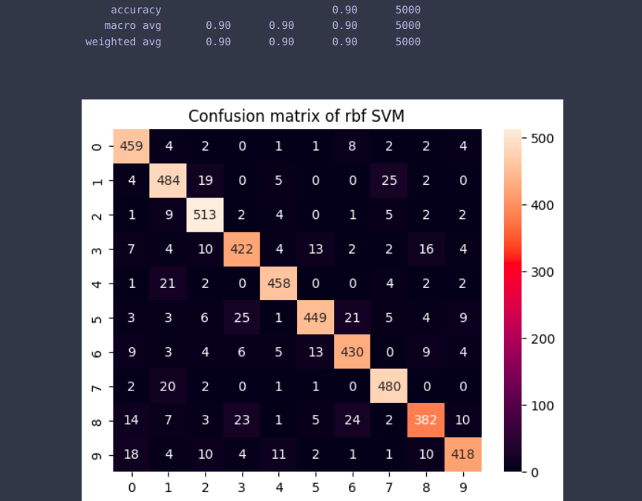
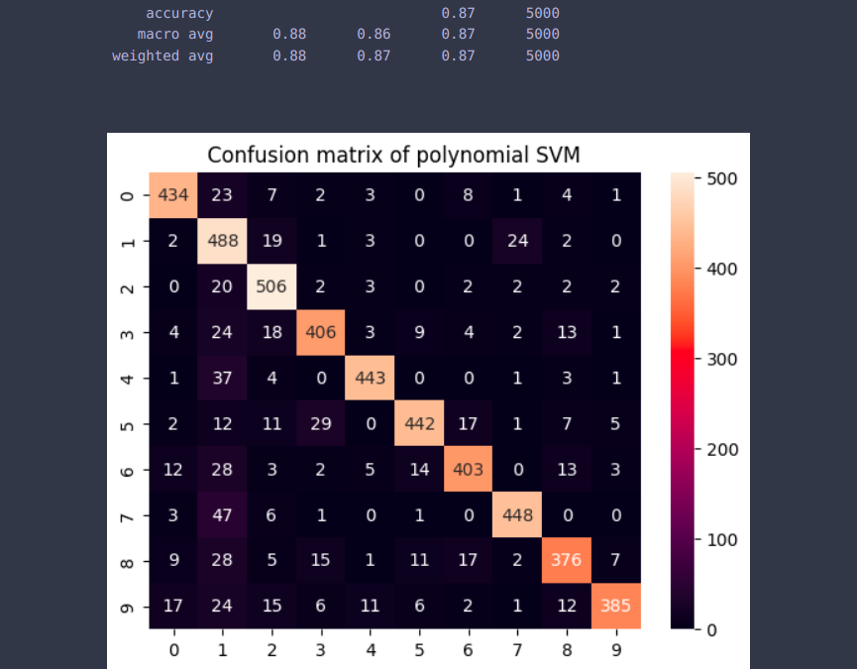

A quick test to find out if an overfit is happening is with train data. If the model has somewhat memorized the train data, the metrics will be very close to 1 or 100%.
To revert the overfit, we can add more train observations, use a method of training with different parts of the dataset, such as cross validation, and also change the default hyperparameters.
SVM Hyperparameters
To see all model parameters that have already been set by Scikit-learn and its default values, we can use the get_params() method. there are a total of 15 hyperparameters already being set.
If we can draw a line to separate our classes, then a linear kernel will be a good option, if we need a curve, then a polynomial kernel might be the best choice, if our data has circular shapes, then a Radial Basis Function or RBF kernel will suit the data better, if there are values above and below a threshold, a sigmoid kernel might separate the classes better.
So far based on accuracy score, we can guess that RBF is the best kernel for our dataset.
The C Hyperparameter
The C parameter is inversely proportional to the margin size, this means that the larger the value of C, the smaller the margin, and, conversely, the smaller the value of C, the larger the margin.
Our RBF kernel SVM has used a C of 1.0, which is a large value and gives a smaller margin.
By using a smaller C and obtaining a larger margin, the classifier has become more flexible and with more classification mistakes.
The accuracy with RBF kernel and C = 10 is 0.90
The accuracy with RBF kernel and C = 1 is 0.89
The accuracy with RBF kernel and C = 0.1 is 0.72
The accuracy with RBF kernel and C = 0.01 is 0.17
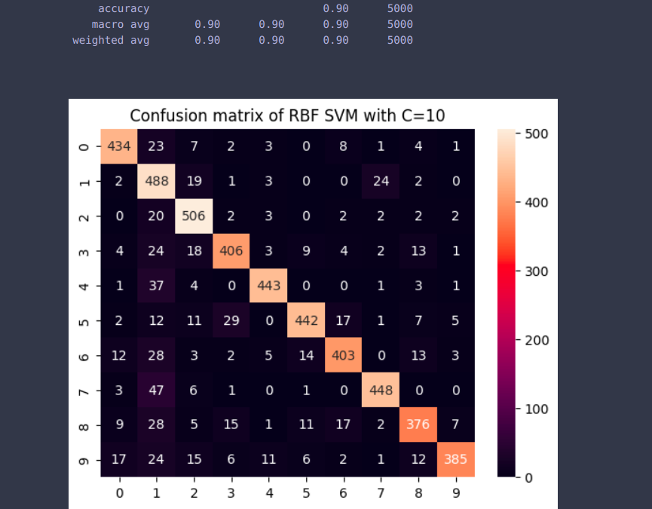
The best SVM would have RBF kernel and C = 10.
Accuracy of test data is 0.90 and train data is 1.0.
The high accuracy for train data does not mean there was an overfitting; Since the model works good on test data. It means the database was easy to classify.

